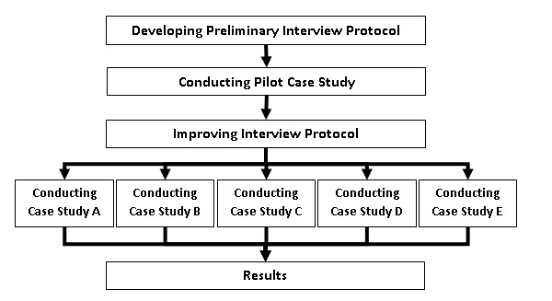
Figure 1 – Research Steps
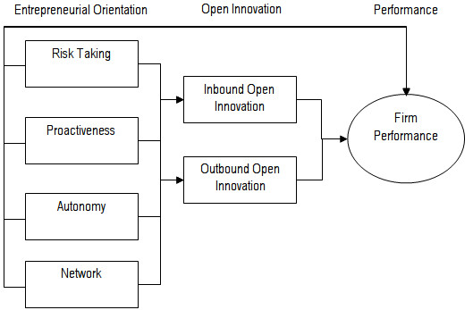
Figure 2 – The proposed conceptual framework.

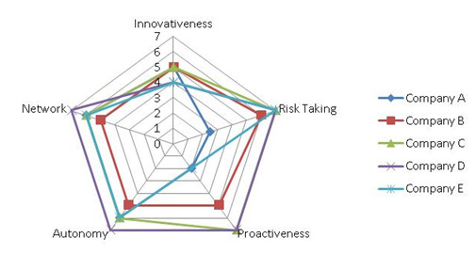
Figure 3 – Entrepreneurial orientation of firms.
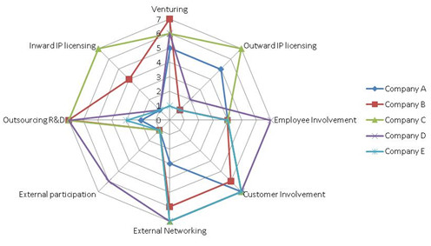
Figure 4 – Open Innovation activities.

